Title: | Door Control Module  SW Component SensorManager

History
Issue status  (Index) | Maturity/Date  (draft/invalid/valid)  (dd-mmm-yyyy) | Author  Department | Check/Release  Department | Description
1.0 | Draft  02-Feb-21 | Rubén Cocoletzi | - | Initial Version

Table of Contents
1 Purpose 3
2 Definitions and abbreviations 3
3 Realization constraints and targets 3
4 SW Conceptual design 4
5 SW Component internal breakdown 4
5.1 Functional Decomposition 4
5.2 Function void SensorManager_Init (void) 5
5.3 Function void GetAdcCounts (int* AdcCounts) 5
5.4 Function void SensorManager_Reading (void) 5

Purpose
This document is created to show the principal behavior of the functions implemented in Door Control Module to read the analog inputs related to the antipinch sensor.

Definitions and abbreviations
Definitions
NA

Abbreviations
References
N° | Document name | Reference
1 | SW Architecture description | Commit: ddc45822a03f9f1781eaa4fc5b6d5874311f8e1b

Realization constraints and targets

This document shows the principal implementation to read the analog input (antipinch sensor).

SW Conceptual design
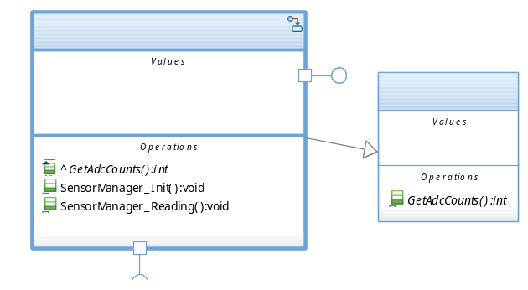

SW Component internal breakdown

Functional Decomposition
Overview of functions and their dependencies shown by a Static Function Tree
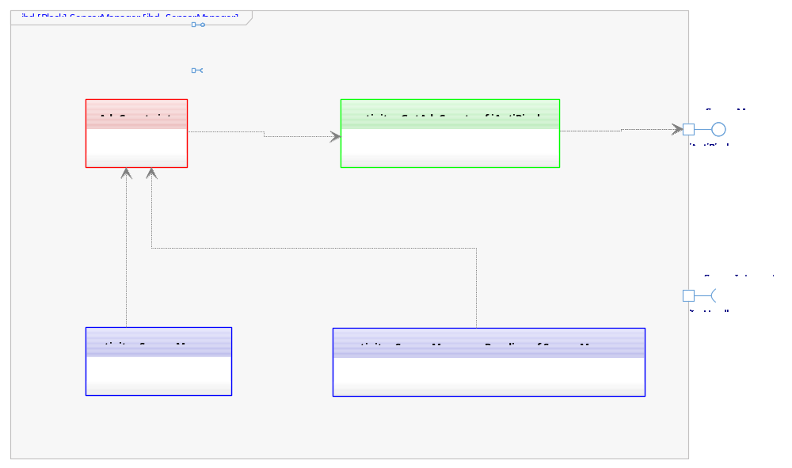

Function Description and Dynamic Behavior

Function void SensorManager_Init (void)

Description | This function initializes the AdcCount variable that will be used to send the current value of the Antipinch sensor.
Parameter 1  <input| output| inout> | NA – Not identified yet
Parameter 2..n | NA – Not identified yet
Return Value | void
Precondition | Function is called by the OS.
Post condition | SensorManager component will have the initialization correctly.
Error Conditions | NA – Not identified yet
Requirements | NA – Not identified yet

Function void GetAdcCounts (int* AdcCounts)
Description | This function is used to return AdcCounts to the components that need this value
Parameter 1  <input| output| inout> | int* AdcCounts <inout> - Return last adc reading from Antipinch sensor
Parameter 2..n | NA – Not identified yet
Return Value | void
Precondition | Function is called by the OS.
Post condition | SafetyManager component will receive the last adc reading from Antipinch sensor.
Error Conditions | NA – Not identified yet
Requirements | NA – Not identified yet

Function void SensorManager_Reading (void)
Description | This function is executed periodically. The execution is implemented with a state machine to show the possible states that SensorManager will have to provide a proper measurement of the Antipinch sensor
Parameter 1  <input| output| inout> | NA – Not identified yet
Parameter 2..n | NA – Not identified yet
Return Value | void
Precondition | Function is called by the OS.
Post condition | SensorManager component will have a proper measurement of Antipinch sensor
Error Conditions | NA – Not identified yet
Requirements | NA – Not identified yet

Dynamic Behavior
State Chart¹

